System Architecture - 2nd Iteration

Advanced Functionality:
In addition to the primary functions (user registration, information storage, Cobb calculation, etc.), further requirements have been proposed to improve the usability of the computer-aided diagnosis system, including:
- Automated / semi-automated algorithm shift
- Lanke classification
- English and Chinese translations
To meet the growing requirements, the original server structure needs to be extended. To be more specific:

- Algorithm Shift:
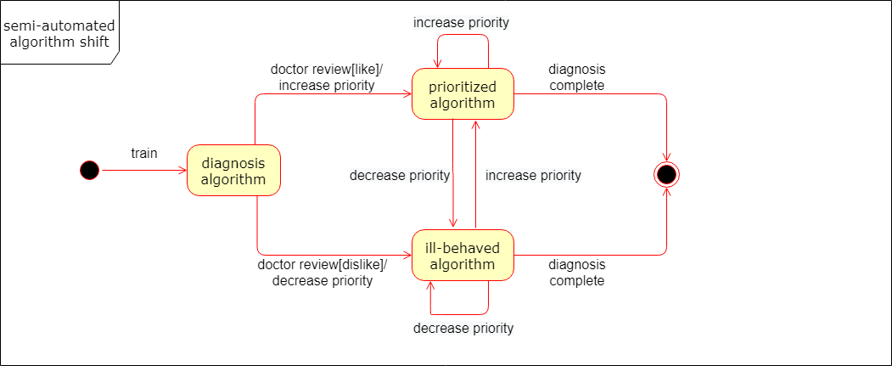
To realize automated or semi-automated algorithm shift, the performance of each algorithm module needs to be evaluated objectively. Considering the fact that the system is developed for computer-aided diagnosis (CAD), we assume that all the doctors involved are well-qualified and authoritative, and the doctors’ remarks will be given the highest priority when comparing and choosing different algorithms.

- Lanke Classification:
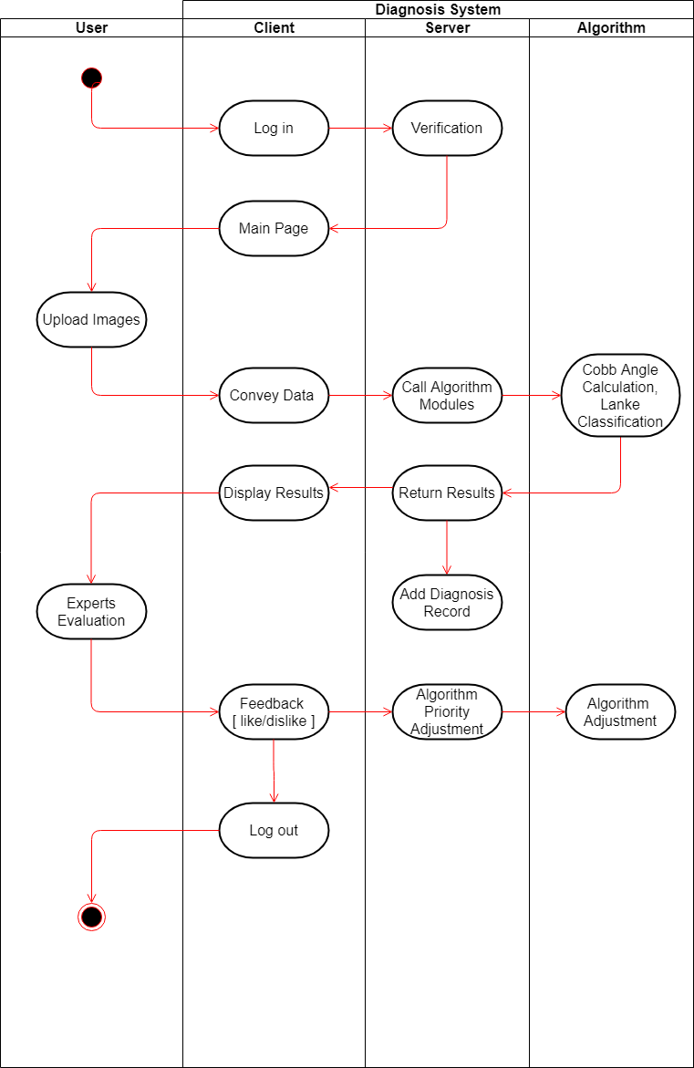
Although the server side is not responsible for the implementation details of the Lanke classification problem, the interface should be adapted accordingly to meet this requirement. In addition to the Cobb angles calculated in the previous steps, the result of Lanke classification will also be passed to the server, and then transferred to the front end. As is mentioned earlier, annotations and remarks from human experts are assumed to be the ground truth, and will be applied to evaluate and prioritize different algorithms later.

- Language Translation:
In an increasingly connected world, multi-language software is becoming more and more common. Considering the audience of this product, a user-friendly language switcher is needed to make the interaction process clearer. While the user interfaces and language options are designed by the client groups, the server should store the configurations and resources to support the implementation of multi-language interaction environment.

Concurrency and System Capacity:
The website should load as quick as possible. Slow load times are a primary reason visitor abandon a checkout process, and a very slow site could be a negative ranking factor for the search engines. To limit the average load time within 3 seconds (an ideal load time for most applications), while the front end groups need to optimize the client-side scripts and tags, the concurrency of the database is also an important factor that determine how fast the system could respond to the user’s request. Generally a transaction on the database could be executed with in 10 ms. Assuming that the quest per second (QPS) is less than 100, the system should be able to respond to the database access requests within 1 second. However, if the number of user grows and exceeds the system capacity, further optimization needs to be adopted, such as proper indexing, SQL tuning, or even applying distributed DBMS for the better response and stability.

A note on image storage:
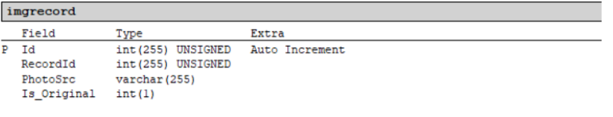
The image data is stored locally, with only image address and corresponding record ID saved in the database. This storage strategy shows greater efficiency, since the image data transition process is extremely time-consuming compared with other database operations.

